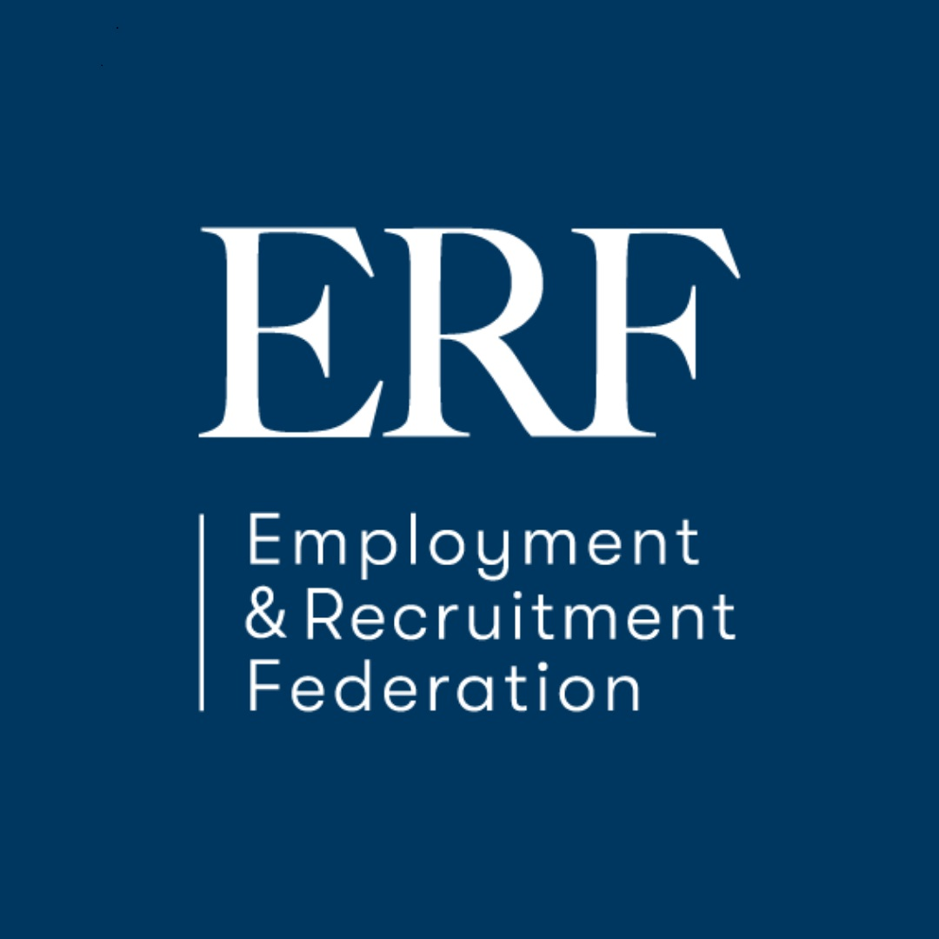

Recruitment Industry Awards 2022

In association with – Bullhorn, LinkedIn & The Irish Independent
Award Category: Unsung Hero Award

Entrant Details
Company Name
Contact Address
Telephone Number |  |  |  | Email
DECLARATION
I hereby certify that the information given in this entry form is correct.

Name: |  |  | Position:
Signed: |  |  | Date:
Rules of Entry
- Application Fee: €50.00 per award
(Please note the fee is €50.00 per award category application)
(See F.A.Q for further details).
- Entry must be based on the last 12 months ONLY
- Please ensure you have registered online for each category you are applying for. Please print off (or email) your completed submission and enclose the completed application form.
- Submit by email to the ERF office. (PLEASE NOTE NEW WORD RESTRICTIONS) (See F.A.Q for further details).
- Strict closing date Thursday 22nd September 2022
The ERF is a GDPR compliant organisation. Please be advised that as a necessity of this process the information you share in your application form will be shared with the judging panel, which comprises of three independent judging panels, the identity of whom we are unable to disclose. Your information is not being transferred outside of the EU.
Photographs of the successful finalists will be published on screen on the night of the awards, and photographs of the winning candidate will be published in the national newspapers, on the ERF website and on screen on the night. Publication of photographs is a mandatory condition of your application and therefore your consent is not required
PLEASE RETURN TO: awards@erfireland.com

Category Award – 2022 Unsung Hero Award

DEADLINE: Thursday 22nd September 2022

Judging Criteria for Unsung Hero Award

This award is for ‘AN INDIVIDUAL’ to receive a special award in recognition of their significant contribution to their company.

The judges will be looking for evidence to support your entry in the following areas:

Criteria | Scoring
Impact:  What does the Individual do on a daily basis which has been a benefit to the business  ( no more than 300 words ) | 20%
Initiative:  Using initiative which demonstrates going above on beyond the call of duty  ( no more than 500 words ) | 40%
Results:  Proudest achievements and accomplishments in the last 12 months/ Specific projects they have taken on, new initiatives or long-term support which has aided in the success of your business.  ( no more than 500 words ) | 40%

PLEASE NOTE THE WORD COUNT
(IF YOU USE EMBEDDED GRAPHICS THESE ARE INCLUDED IN THE WORD COUNT)
STRICTLY - NO MORE THAN 4 PAGES

